RIX 2024 - Batch 1- Selenium Practical Assessment
12576 Nisanth Saravanan

Online Courier Management System

An online courier management system is a software application that is used to manage the process of sending and tracking packages and documents through a courier service. This typically includes functions such as creating shipping labels, tracking packages, and generating reports. This project is a useful tool for businesses and individuals who need to send packages and documents through a courier service on a regular basis.

W3H Analysis

Project Title: Online Courier Management System
What? |  | How?
1. What are the necessary modules?  A: Modules Needed:  1) Login and Registration.  2) Admin Dashboard.  3)User Dashboard.  2. What are the necessary functionalities of Login and Registration Modules?  A: Login and Registration Module:  1) Register User.  2) Login as User.  3) Login as Admin.  3. What are the necessary functionalities of Admin Dashboard?  A: Admin Dashboard:  1) Perform CRUD Operation with Shipments.  2) Filter Shipments.  4. What are the necessary functionalities of User Dashboard?  A: User Dashboard:  1) Filter Shipments.  5. What are the tables needed?  A: Tables Required:  - Shipments  - Users  6. What are the fields of user table?  A: Fields of Users table:  - Id (Primary Key) - int  - Name – string  - Password – string  - Role – string  7. What are the fields of the Shipment table?  A: Fields of Shipment Table:  - Id (Primary Key) - int  - Name – string  - Type – string  - Address – string  8. What are the two values of the Role Field in the User table?  A: Admin Role  User Role  9. What are the must have dependencies?  A: Dependencies:  - axios  - react-router-dom  - toastr  10. What are the validations in the application?  A: Overall validations list:  - Frontend simple JS Validations.  - Server Side validations.  - Form Validations. |  | Login and Registration Module:  1) Register User:  Method 1: Use Simple Form Page.  Method 2: Use a Modular Form Page.  Method 3: Use Google OAuth and other 3rd party services.  2) Login as User:  Method 1: Use Simple Form.  Method 2: Use a Modular Form.  Method 3: Use 3rd party services.  3) Login as Admin:  Method 1: Hard Code the Admin accounts.  Method 2: Have an Admin Login Page.  Method 3: Have a separate Register + Login for admins.  Admin Dashboard:  1) Perform CRUD Operation with Shipments:  Method 1: Use Simple Forms and Buttons to perform CRUD.  Method 2: Have separate pages for each operation  Method 3: Use Modals.  2) Filter Shipments:  Method 1: Use a simple search bar.  Method 2: Have tables and sorting buttons.  Method 3: Have a separate page to pick out exact results.  User Dashboard:  1) Filter Shipments:  Method 1: Use a simple search bar.  Method 2: Have tables and sorting buttons.  Method 3: Have a separate page to pick out exact results.
Login and Registration Module:  1) Register User:  Method 1: Use Simple Form Page.  A: Since the overall scale of the application is small and data needed is rather minimal, it’s wise to stick with traditional forms.  2) Login as User:  Method 1: Use Simple Form.  A: Since the overall scale of the application is small and data needed is rather minimal, it’s wise to stick with traditional forms.  3) Login as Admin:  Method 1: Hard Code the Admin accounts.  A: It’s best to hard code admin users to ensure security and have only one or two admin users in total.  Admin Dashboard:  1) Perform CRUD Operation with Shipments:  Method 1: Use Simple Forms and Buttons to perform CRUD.  A: Since the overall scale of the application is small and data needed is rather minimal, it’s wise to stick with traditional forms.  2) Filter Shipments:  Method 1: Use a simple search bar.  A: Effective as it may, the simple input field can be directly mapped with the shipments that are being displayed.  User Dashboard:  1) Filter Shipments:  Method 1: Use a simple search bar.  A: Effective as it may, the simple input field can be directly mapped with the shipments that are being displayed. |  | Login and Registration Module:  1) Register User:  Method 2: Use a Modular Form Page.  A: Increases the complexity of the app, and also the fact that the number of needed inputs in rather minimal.  Method 3: Use Google OAuth and other 3rd party services.  A: Valid method but due to the scale of the application, this method is seemingly overkill.  2) Login as User:  Method 2: Use a Modular Form.  A: Increases the complexity of the app, and also the fact that the number of needed inputs in rather minimal.  Method 3: Use 3rd party services.  A: Valid method but due to the scale of the application, this method is seemingly overkill.  3) Login as Admin:  Method 2: Have an Admin Login Page.  A: Best not to have an admin login page distinctively when the primary user of the app is regular customers.  Method 3: Have a separate Register + Login for admins.  A: This increases the number of pages to be developed and also leaves open a vulnerable endpoint for someone to register as administrator.  Admin Dashboard:  1) Perform CRUD Operation with Shipments:  Method 2: Have separate pages for each operation.  A: Since the admin needs all information in one place and also that the number of operations they can do is limited, it is best to have a single page control centre type.  Method 3: Use Modals.  A: Seeing that the number of input fields are minimal, and asking for user input using modals is seemingly overkill.  2) Filter Shipments:  Method 2: Have tables and sorting buttons.  A: This method is also viable but not selected due to the slight increase in the number of code needed for its execution.  Method 3: Have a separate page to pick out exact results.  A: Having the all the data displayed in one page and search functionality in another is not idle. Hence, this method is rejected.  User Dashboard:  1) Filter Shipments:  Method 2: Have tables and sorting buttons.  A: This method is also viable but not selected due to the slight increase in the number of code needed for its execution.  Method 3: Have a separate page to pick out exact results.  A: Having the all the data displayed in one page and search functionality in another is not idle. Hence, this method is rejected.
Why? |  | Why Not?

Output Screenshots

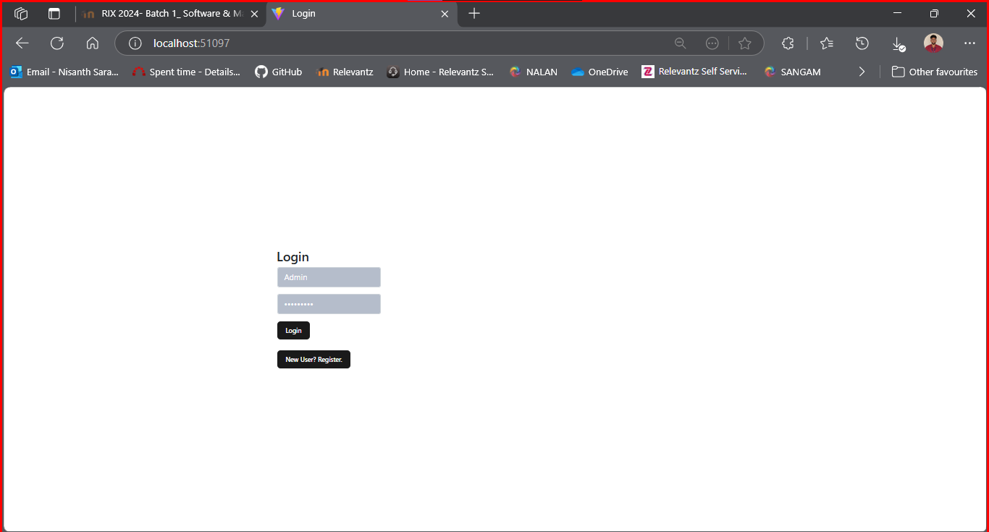

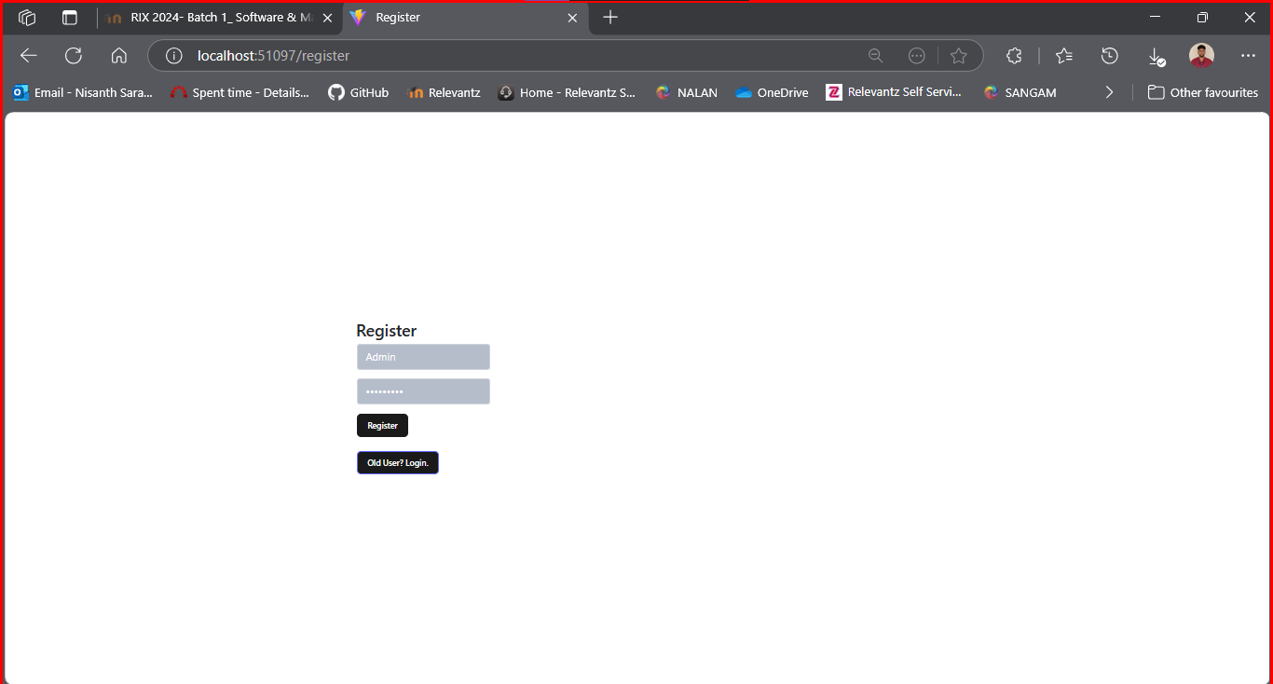

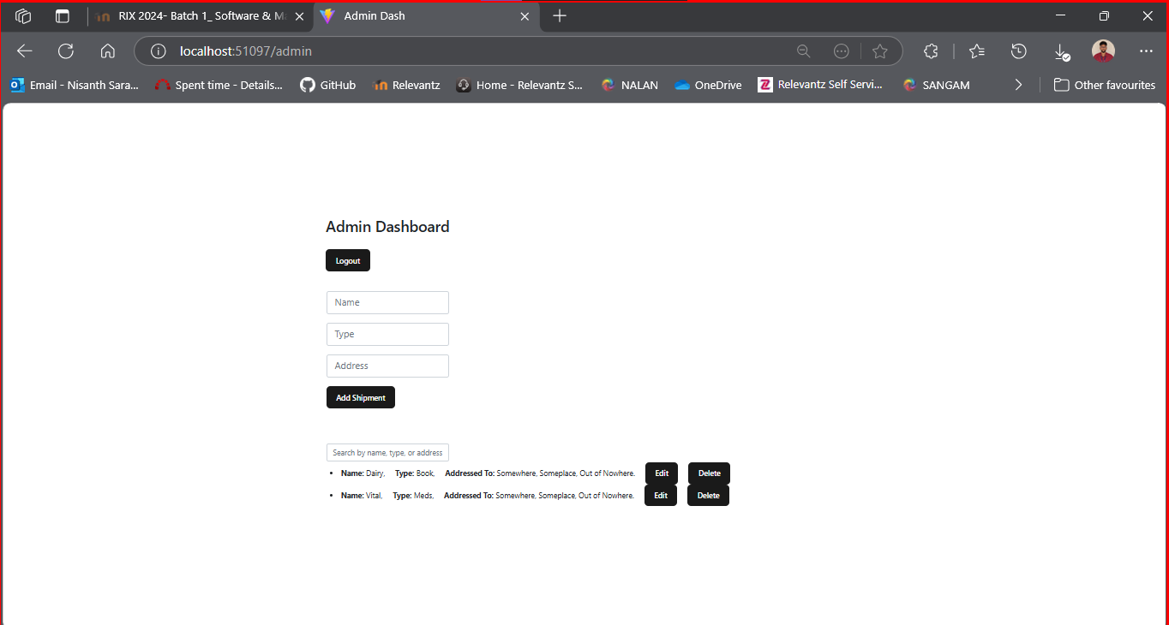

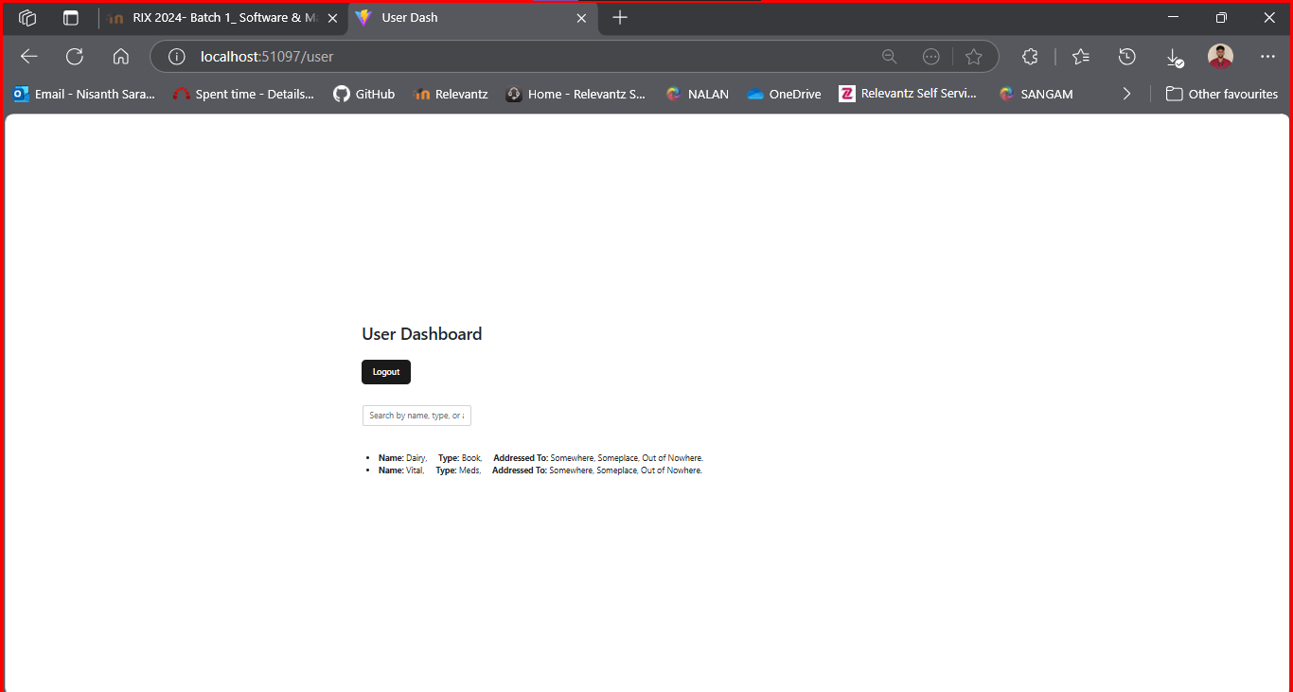
Testing:
AdminUserSeleniumTester

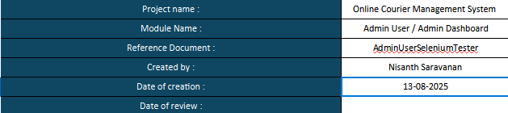
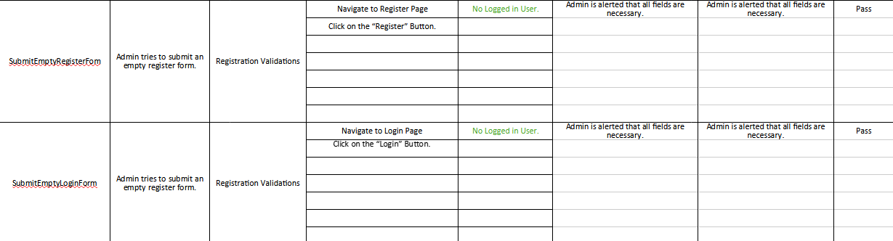
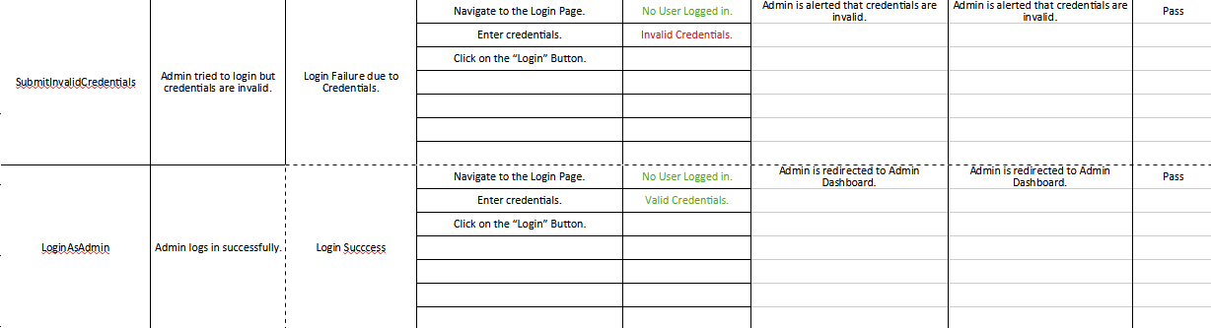
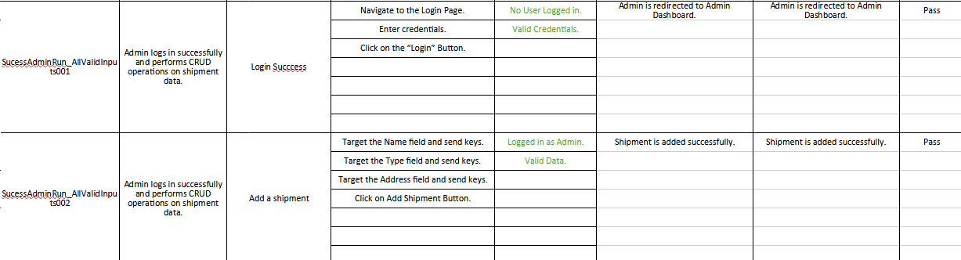
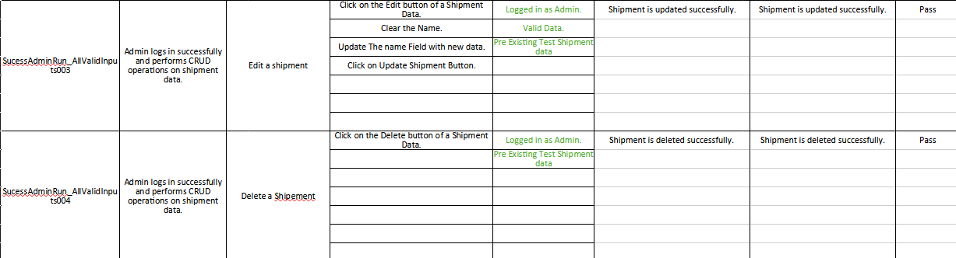
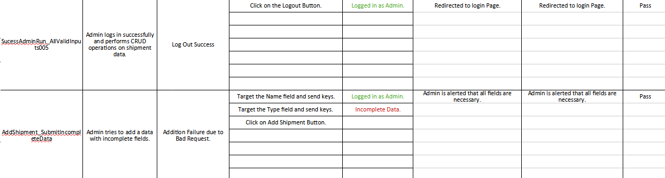
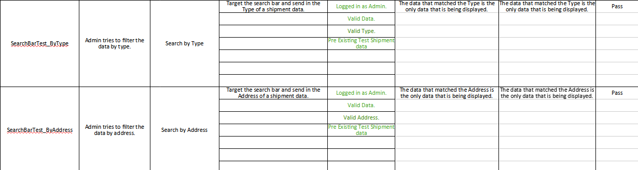
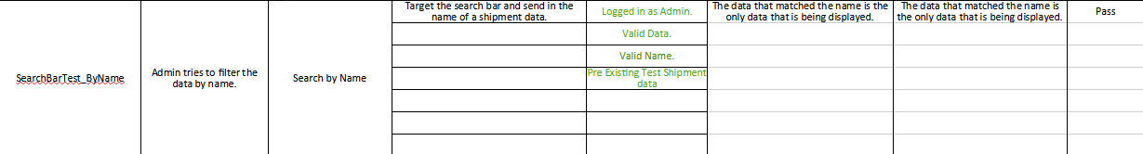

using OpenQA.Selenium;
using OpenQA.Selenium.Chrome;

class Program
{
public static void Main (string[] args)
{
//SetUp
IWebDriver driver = new ChromeDriver();
driver.Manage().Window.Maximize();

SubmitEmptyRegisterFom(driver);

SubmitEmptyLoginForm(driver);

SubmitInvalidCredentials(driver);

LoginAsAdmin(driver);

SuccessAdminRun_AllValidInputs(driver);

AddShipment_SubmitIncompleteData(driver);

SearchBarTest_ByName(driver);

SearchBarTest_ByType(driver);

SearchBarTest_ByAddress(driver);

EditShipment_SubmitIncompleteData(driver);

//TearDown.
driver.Close();
driver.Quit();
}

static void SubmitEmptyRegisterFom(IWebDriver driver)
{
try
{
//Start from Register Page.
driver.Navigate().GoToUrl("http://localhost:3000/register");
Thread.Sleep(2000);

//Submit Empty Register Form.
driver.FindElement(By.XPath("//button[text()='Register']")).Click();
Thread.Sleep(2000);
IAlert alert = driver.SwitchTo().Alert();
alert.Accept();
Thread.Sleep(2000);
}
catch (Exception ex)
{
Console.WriteLine(ex.Message);
}
}

static void SubmitEmptyLoginForm(IWebDriver driver)
{
try
{
//Start from Login Page.
driver.Navigate().GoToUrl("http://localhost:3000/");
Thread.Sleep(2000);

//Submit Empty Login Form.
driver.FindElement(By.XPath("//button[text()='Login']")).Click();
Thread.Sleep(2000);
IAlert alert = driver.SwitchTo().Alert();
alert.Accept();
Thread.Sleep(2000);
} catch (Exception ex)
{
Console.WriteLine(ex.Message);
}
}

static void SubmitInvalidCredentials(IWebDriver driver)
{
try
{
//Start from Login Page.
driver.Navigate().GoToUrl("http://localhost:3000/");
Thread.Sleep(2000);

//Submit Invalid Credentials.
driver.FindElement(By.XPath("//input[@placeholder='Username']")).SendKeys("Someone Else");
driver.FindElement(By.XPath("//input[@placeholder='Password']")).SendKeys("Somebody@123");
driver.FindElement(By.XPath("//button[text()='Login']")).Click();
Thread.Sleep(2000);
IAlert alert = driver.SwitchTo().Alert();
alert.Accept();
Thread.Sleep(2000);
}
catch (Exception ex) {
Console.WriteLine(ex.Message);
}
}

static void LoginAsAdmin(IWebDriver driver)
{
try
{
//Start from Login Page.
driver.Navigate().GoToUrl("http://localhost:3000/");
Thread.Sleep(2000);

//Login as an "User" User.
driver.FindElement(By.XPath("//input[@placeholder='Username']")).SendKeys("Admin");
driver.FindElement(By.XPath("//input[@placeholder='Password']")).SendKeys("Admin@123");
driver.FindElement(By.XPath("//button[text()='Login']")).Click();
Thread.Sleep(2000);
}
catch (Exception ex)
{
Console.WriteLine(ex.Message);
}
}

static void SuccessAdminRun_AllValidInputs(IWebDriver driver)
{
try
{
LoginAsAdmin(driver);

//Add a shipment.
driver.FindElement(By.XPath("//input[@placeholder='Name']")).SendKeys("Box A");
driver.FindElement(By.XPath("//input[@placeholder='Type']")).SendKeys("Games");
driver.FindElement(By.XPath("//input[@placeholder='Address']")).SendKeys("123 Avenue");
driver.FindElement(By.XPath("//button[text()='Add Shipment']")).Click();
Thread.Sleep(2000);

//Edit a shipment.
driver.FindElement(By.XPath("//button[text()='Edit']")).Click();
Thread.Sleep(2000);
driver.FindElement(By.XPath("//input[@placeholder='Name']")).Clear();
driver.FindElement(By.XPath("//input[@placeholder='Name']")).SendKeys("Updated Box A");
driver.FindElement(By.XPath("//button[text()='Update Shipment']")).Click();
Thread.Sleep(2000);

//Delete a shipment.
driver.FindElement(By.XPath("//button[text()='Delete']")).Click();
Thread.Sleep(2000);

//Logout.
driver.FindElement(By.XPath("//button[text()='Logout']")).Click();
Thread.Sleep(2000);
}
catch (Exception ex)
{
Console.WriteLine(ex.Message);
}
}

static void AddShipment_SubmitIncompleteData(IWebDriver driver)
{
try
{
LoginAsAdmin(driver);

//Add a shipment.
driver.FindElement(By.XPath("//input[@placeholder='Name']")).SendKeys("Box A");
driver.FindElement(By.XPath("//input[@placeholder='Type']")).SendKeys("Games");
driver.FindElement(By.XPath("//button[text()='Add Shipment']")).Click();
Thread.Sleep(2000);
IAlert alert = driver.SwitchTo().Alert();
alert.Accept();
Thread.Sleep(2000);
}
catch (Exception ex)
{
Console.WriteLine(ex.Message);
}
}

static void SearchBarTest_ByName(IWebDriver driver)
{
try
{
LoginAsAdmin(driver);

//Add a shipment.
driver.FindElement(By.XPath("//input[@placeholder='Name']")).SendKeys("Box A");
driver.FindElement(By.XPath("//input[@placeholder='Type']")).SendKeys("Games");
driver.FindElement(By.XPath("//input[@placeholder='Address']")).SendKeys("123 Avenue");
driver.FindElement(By.XPath("//button[text()='Add Shipment']")).Click();
Thread.Sleep(2000);

//Add a shipment.
driver.FindElement(By.XPath("//input[@placeholder='Name']")).SendKeys("Box B");
driver.FindElement(By.XPath("//input[@placeholder='Type']")).SendKeys("Movies");
driver.FindElement(By.XPath("//input[@placeholder='Address']")).SendKeys("456 Avenue");
driver.FindElement(By.XPath("//button[text()='Add Shipment']")).Click();
Thread.Sleep(2000);

//Send keys to search bar and delete.
driver.FindElement(By.XPath("//input[@placeholder='Search by name, type, or address']")).SendKeys("Box A");
Thread.Sleep(2000);
driver.FindElement(By.XPath("//button[text()='Delete']")).Click();
Thread.Sleep(2000);

//Send keys to search bar and delete.
driver.FindElement(By.XPath("//input[@placeholder='Search by name, type, or address']")).Clear();
driver.FindElement(By.XPath("//input[@placeholder='Search by name, type, or address']")).SendKeys("Box B");
Thread.Sleep(2000);
driver.FindElement(By.XPath("//button[text()='Delete']")).Click();
Thread.Sleep(2000);
}
catch (Exception ex)
{
Console.WriteLine(ex.Message);
}
}

static void SearchBarTest_ByType(IWebDriver driver)
{
try
{
LoginAsAdmin(driver);

//Add a shipment.
driver.FindElement(By.XPath("//input[@placeholder='Name']")).SendKeys("Box A");
driver.FindElement(By.XPath("//input[@placeholder='Type']")).SendKeys("Games");
driver.FindElement(By.XPath("//input[@placeholder='Address']")).SendKeys("123 Avenue");
driver.FindElement(By.XPath("//button[text()='Add Shipment']")).Click();
Thread.Sleep(2000);

//Add a shipment.
driver.FindElement(By.XPath("//input[@placeholder='Name']")).SendKeys("Box B");
driver.FindElement(By.XPath("//input[@placeholder='Type']")).SendKeys("Movies");
driver.FindElement(By.XPath("//input[@placeholder='Address']")).SendKeys("456 Avenue");
driver.FindElement(By.XPath("//button[text()='Add Shipment']")).Click();
Thread.Sleep(2000);

//Send keys to search bar and delete.
driver.FindElement(By.XPath("//input[@placeholder='Search by name, type, or address']")).SendKeys("Games");
Thread.Sleep(2000);
driver.FindElement(By.XPath("//button[text()='Delete']")).Click();
Thread.Sleep(2000);

//Send keys to search bar and delete.
driver.FindElement(By.XPath("//input[@placeholder='Search by name, type, or address']")).Clear();
driver.FindElement(By.XPath("//input[@placeholder='Search by name, type, or address']")).SendKeys("Movies");
Thread.Sleep(2000);
driver.FindElement(By.XPath("//button[text()='Delete']")).Click();
Thread.Sleep(2000);
}
catch (Exception ex)
{
Console.WriteLine(ex.Message);
}
}

static void SearchBarTest_ByAddress(IWebDriver driver)
{
try
{
LoginAsAdmin(driver);

//Add a shipment.
driver.FindElement(By.XPath("//input[@placeholder='Name']")).SendKeys("Box A");
driver.FindElement(By.XPath("//input[@placeholder='Type']")).SendKeys("Games");
driver.FindElement(By.XPath("//input[@placeholder='Address']")).SendKeys("123 Avenue");
driver.FindElement(By.XPath("//button[text()='Add Shipment']")).Click();
Thread.Sleep(2000);

//Add a shipment.
driver.FindElement(By.XPath("//input[@placeholder='Name']")).SendKeys("Box B");
driver.FindElement(By.XPath("//input[@placeholder='Type']")).SendKeys("Movies");
driver.FindElement(By.XPath("//input[@placeholder='Address']")).SendKeys("456 Avenue");
driver.FindElement(By.XPath("//button[text()='Add Shipment']")).Click();
Thread.Sleep(2000);

//Send keys to search bar and delete.
driver.FindElement(By.XPath("//input[@placeholder='Search by name, type, or address']")).SendKeys("123");
Thread.Sleep(2000);
driver.FindElement(By.XPath("//button[text()='Delete']")).Click();
Thread.Sleep(2000);

//Send keys to search bar and delete.
driver.FindElement(By.XPath("//input[@placeholder='Search by name, type, or address']")).Clear();
driver.FindElement(By.XPath("//input[@placeholder='Search by name, type, or address']")).SendKeys("456");
Thread.Sleep(2000);
driver.FindElement(By.XPath("//button[text()='Delete']")).Click();
Thread.Sleep(2000);
}
catch (Exception ex)
{
Console.WriteLine(ex.Message);
}
}

static void EditShipment_SubmitIncompleteData(IWebDriver driver)
{
try
{
LoginAsAdmin(driver);

//Add a shipment.
driver.FindElement(By.XPath("//input[@placeholder='Name']")).SendKeys("Box A");
driver.FindElement(By.XPath("//input[@placeholder='Type']")).SendKeys("Games");
driver.FindElement(By.XPath("//input[@placeholder='Address']")).SendKeys("123 Avenue");
driver.FindElement(By.XPath("//button[text()='Add Shipment']")).Click();
Thread.Sleep(2000);

//Edit a shipment.
driver.FindElement(By.XPath("//button[text()='Edit']")).Click();
Thread.Sleep(2000);
driver.FindElement(By.XPath("//input[@placeholder='Name']")).Clear();
Thread.Sleep(2000);
driver.FindElement(By.XPath("//button[text()='Update Shipment']")).Click();
Thread.Sleep(2000);
IAlert alert = driver.SwitchTo().Alert();
alert.Accept();
Thread.Sleep(2000);
}
catch(Exception ex)
{
Console.WriteLine(ex.Message);
}
}
}

UserRoleSeleniumTester

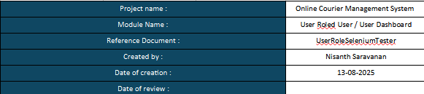
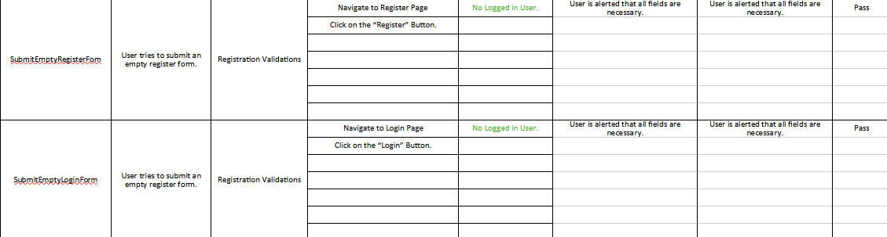
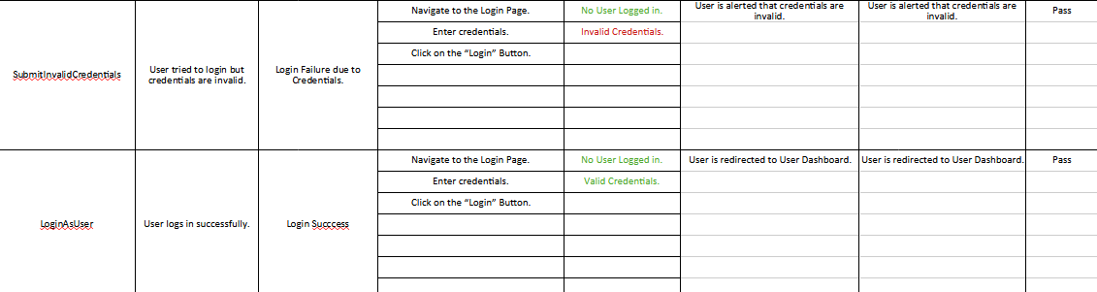
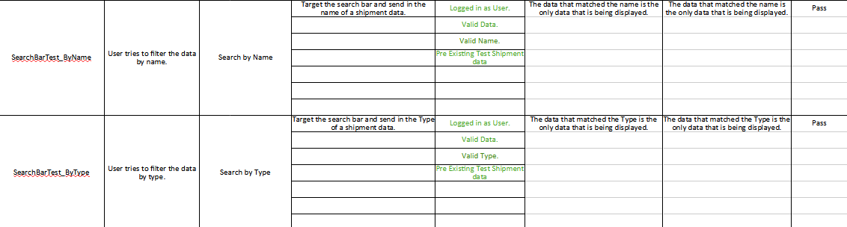
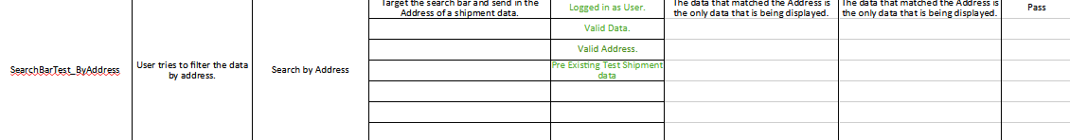

using OpenQA.Selenium;
using OpenQA.Selenium.Chrome;

class Program
{
public static void Main(string[] args)
{
//SetUp
IWebDriver driver = new ChromeDriver();
driver.Manage().Window.Maximize();

//Admin Side Preset.
try
{
//Start from Login Page.
driver.Navigate().GoToUrl("http://localhost:3000/");
Thread.Sleep(2000);

//Login as an "Admin" User.
driver.FindElement(By.XPath("//input[@placeholder='Username']")).SendKeys("Admin");
driver.FindElement(By.XPath("//input[@placeholder='Password']")).SendKeys("Admin@123");
driver.FindElement(By.XPath("//button[text()='Login']")).Click();
Thread.Sleep(2000);

//Add a shipment.
driver.FindElement(By.XPath("//input[@placeholder='Name']")).SendKeys("Box A");
driver.FindElement(By.XPath("//input[@placeholder='Type']")).SendKeys("Games");
driver.FindElement(By.XPath("//input[@placeholder='Address']")).SendKeys("123 Avenue");
driver.FindElement(By.XPath("//button[text()='Add Shipment']")).Click();
Thread.Sleep(2000);

//Add a shipment.
driver.FindElement(By.XPath("//input[@placeholder='Name']")).SendKeys("Box B");
driver.FindElement(By.XPath("//input[@placeholder='Type']")).SendKeys("Movies");
driver.FindElement(By.XPath("//input[@placeholder='Address']")).SendKeys("456 Avenue");
driver.FindElement(By.XPath("//button[text()='Add Shipment']")).Click();
Thread.Sleep(2000);
}
catch (Exception ex)
{
Console.WriteLine(ex.Message);
}

SubmitEmptyRegisterFom(driver);

RegisterAsUser(driver);

SubmitEmptyLoginForm(driver);

SubmitInvalidCredentials(driver);

LoginAsUser(driver);

SearchBarTest_ByName(driver);

SearchBarTest_ByType(driver);

SearchBarTest_ByAddress(driver);

//TearDown.
try
{
//End from Login Page.
driver.Navigate().GoToUrl("http://localhost:3000/");
Thread.Sleep(2000);

//Login as an "Admin" User.
driver.FindElement(By.XPath("//input[@placeholder='Username']")).SendKeys("Admin");
driver.FindElement(By.XPath("//input[@placeholder='Password']")).SendKeys("Admin@123");
driver.FindElement(By.XPath("//button[text()='Login']")).Click();
Thread.Sleep(2000);

//Delete sample data.
driver.FindElement(By.XPath("//button[text()='Delete']")).Click();
Thread.Sleep(2000);
driver.FindElement(By.XPath("//button[text()='Delete']")).Click();
Thread.Sleep(2000);
}
catch (Exception ex)
{
Console.WriteLine(ex.Message);
}

driver.Close();
driver.Quit();
}

static void SubmitEmptyRegisterFom(IWebDriver driver)
{
try
{
//Start from Register Page.
driver.Navigate().GoToUrl("http://localhost:3000/register");
Thread.Sleep(2000);

//Submit Empty Register Form.
driver.FindElement(By.XPath("//button[text()='Register']")).Click();
Thread.Sleep(2000);
IAlert alert = driver.SwitchTo().Alert();
alert.Accept();
Thread.Sleep(2000);
}
catch(Exception ex)
{
Console.WriteLine(ex.Message);
}
}

static void RegisterAsUser(IWebDriver driver)
{
try
{
//Start from Register Page.
driver.Navigate().GoToUrl("http://localhost:3000/register");
Thread.Sleep(2000);

//Submit Valid Creadentials.
driver.FindElement(By.XPath("//input[@placeholder='Username']")).SendKeys("Someone");
driver.FindElement(By.XPath("//input[@placeholder='Password']")).SendKeys("Somebody@123");
driver.FindElement(By.XPath("//button[text()='Register']")).Click();
Thread.Sleep(2000);
IAlert alert = driver.SwitchTo().Alert();
alert.Accept();
Thread.Sleep(2000);
}
catch (Exception ex)
{
Console.WriteLine(ex.Message);
}
}

static void SubmitEmptyLoginForm(IWebDriver driver)
{
try
{
//Start from Login Page.
driver.Navigate().GoToUrl("http://localhost:3000/");
Thread.Sleep(2000);

//Submit Empty Login Form.
driver.FindElement(By.XPath("//button[text()='Login']")).Click();
Thread.Sleep(2000);
IAlert alert = driver.SwitchTo().Alert();
alert.Accept();
Thread.Sleep(2000);
}
catch (Exception ex)
{
Console.WriteLine(ex.Message);
}
}

static void SubmitInvalidCredentials(IWebDriver driver)
{
try
{
//Start from Login Page.
driver.Navigate().GoToUrl("http://localhost:3000/");
Thread.Sleep(2000);

//Submit Invalid Creadentials.
driver.FindElement(By.XPath("//input[@placeholder='Username']")).SendKeys("Someone Else");
driver.FindElement(By.XPath("//input[@placeholder='Password']")).SendKeys("Somebody@123");
driver.FindElement(By.XPath("//button[text()='Login']")).Click();
Thread.Sleep(2000);
IAlert alert = driver.SwitchTo().Alert();
alert.Accept();
Thread.Sleep(2000);
}
catch(Exception ex)
{
Console.WriteLine(ex.Message);
}
}

static void LoginAsUser(IWebDriver driver)
{
try
{
//Start from Login Page.
driver.Navigate().GoToUrl("http://localhost:3000/");
Thread.Sleep(2000);

//Login as an "User" User.
driver.FindElement(By.XPath("//input[@placeholder='Username']")).SendKeys("User306");
driver.FindElement(By.XPath("//input[@placeholder='Password']")).SendKeys("User@123");
driver.FindElement(By.XPath("//button[text()='Login']")).Click();
Thread.Sleep(2000);
}
catch(Exception ex)
{
Console.WriteLine(ex.Message);
}
}

static void SearchBarTest_ByName(IWebDriver driver)
{
try
{
LoginAsUser(driver);

//Send keys to search bar.
driver.FindElement(By.XPath("//input[@placeholder='Search by name, type, or address']")).SendKeys("Box A");
Thread.Sleep(2000);

//Send keys to search bar.
driver.FindElement(By.XPath("//input[@placeholder='Search by name, type, or address']")).Clear();
driver.FindElement(By.XPath("//input[@placeholder='Search by name, type, or address']")).SendKeys("Box B");
Thread.Sleep(2000);
}
catch(Exception ex)
{
Console.WriteLine(ex.Message);
}
}

static void SearchBarTest_ByType(IWebDriver driver)
{
try
{
LoginAsUser(driver);

//Send keys to search bar.
driver.FindElement(By.XPath("//input[@placeholder='Search by name, type, or address']")).SendKeys("Games");
Thread.Sleep(2000);

//Send keys to search bar.
driver.FindElement(By.XPath("//input[@placeholder='Search by name, type, or address']")).Clear();
driver.FindElement(By.XPath("//input[@placeholder='Search by name, type, or address']")).SendKeys("Movies");
Thread.Sleep(2000);
}
catch(Exception ex)
{
Console.WriteLine(ex.Message);
}
}

static void SearchBarTest_ByAddress(IWebDriver driver)
{
try
{
LoginAsUser(driver);

//Send keys to search bar.
driver.FindElement(By.XPath("//input[@placeholder='Search by name, type, or address']")).SendKeys("123");
Thread.Sleep(2000);

//Send keys to search bar.
driver.FindElement(By.XPath("//input[@placeholder='Search by name, type, or address']")).Clear();
driver.FindElement(By.XPath("//input[@placeholder='Search by name, type, or address']")).SendKeys("456");
Thread.Sleep(2000);
}
catch (Exception ex)
{
Console.WriteLine(ex.Message);
}
}
}

RegisterAndLoginSeleniumTester

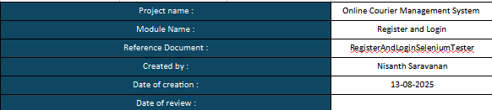
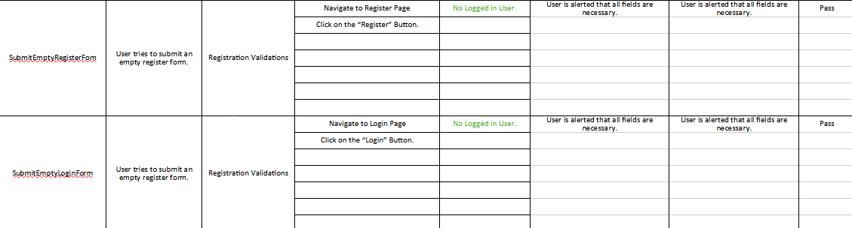
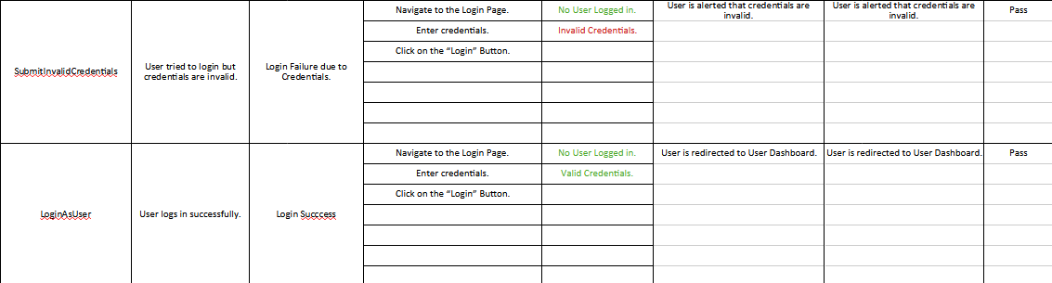
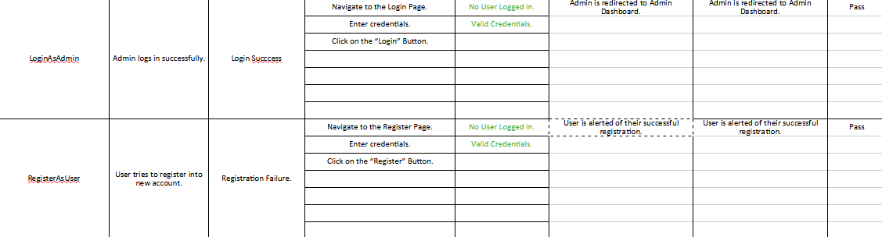
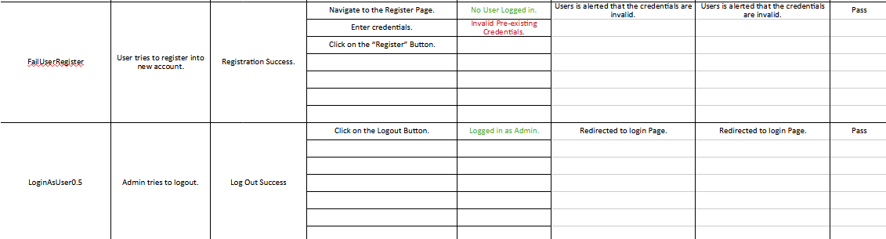
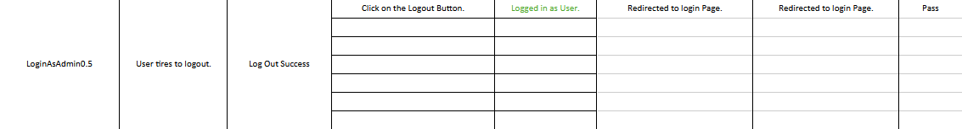

using OpenQA.Selenium;
using OpenQA.Selenium.Chrome;

class Program
{
public static void Main(string[] args)
{
//SetUp
IWebDriver driver = new ChromeDriver();
driver.Manage().Window.Maximize();

SubmitEmptyRegisterFom(driver);

SubmitEmptyLoginForm(driver);

SubmitInvalidCredentials(driver);

RegisterAsUser(driver);

FailUserRegister(driver);

LoginAsAdmin(driver);

LoginAsUser(driver);

//TearDown.
driver.Close();
driver.Quit();
}

static void SubmitEmptyRegisterFom(IWebDriver driver)
{
try
{
//Start from Register Page.
driver.Navigate().GoToUrl("http://localhost:3000/register");
Thread.Sleep(2000);

//Submit Empty Register Form.
driver.FindElement(By.XPath("//button[text()='Register']")).Click();
Thread.Sleep(2000);
IAlert alert = driver.SwitchTo().Alert();
alert.Accept();
Thread.Sleep(2000);
}
catch (Exception ex)
{
Console.WriteLine(ex.Message);
}
}

static void SubmitEmptyLoginForm(IWebDriver driver)
{
try
{
//Start from Login Page.
driver.Navigate().GoToUrl("http://localhost:3000/");
Thread.Sleep(2000);

//Submit Empty Login Form.
driver.FindElement(By.XPath("//button[text()='Login']")).Click();
Thread.Sleep(2000);
IAlert alert = driver.SwitchTo().Alert();
alert.Accept();
Thread.Sleep(2000);
}
catch(Exception ex)
{
Console.WriteLine(ex.Message);
}
}

static void SubmitInvalidCredentials(IWebDriver driver)
{
try
{
//Start from Login Page.
driver.Navigate().GoToUrl("http://localhost:3000/");
Thread.Sleep(2000);

//Submit Invalid Credentials.
driver.FindElement(By.XPath("//input[@placeholder='Username']")).SendKeys("Someone else");
driver.FindElement(By.XPath("//input[@placeholder='Password']")).SendKeys("Somebody@123");
driver.FindElement(By.XPath("//button[text()='Login']")).Click();
Thread.Sleep(2000);
IAlert alert = driver.SwitchTo().Alert();
alert.Accept();
Thread.Sleep(2000);
}
catch (Exception ex)
{
Console.WriteLine(ex.Message);
}
}

static void RegisterAsUser(IWebDriver driver)
{
try
{
//Start from Register Page.
driver.Navigate().GoToUrl("http://localhost:3000/register");
Thread.Sleep(2000);

//Submit Valid Credentials.
driver.FindElement(By.XPath("//input[@placeholder='Username']")).SendKeys("Someone in the wind.");
driver.FindElement(By.XPath("//input[@placeholder='Password']")).SendKeys("Somebody@123");
driver.FindElement(By.XPath("//button[text()='Register']")).Click();
Thread.Sleep(2000);
IAlert alert = driver.SwitchTo().Alert();
alert.Accept();
Thread.Sleep(2000);
}
catch(Exception ex)
{
Console.WriteLine(ex.Message);
}
}

static void FailUserRegister(IWebDriver driver)
{
try
{
//Start from Register Page.
driver.Navigate().GoToUrl("http://localhost:3000/register");
Thread.Sleep(2000);

//Submit Valid Credentials.
driver.FindElement(By.XPath("//input[@placeholder='Username']")).SendKeys("Someone in the wind.");
driver.FindElement(By.XPath("//input[@placeholder='Password']")).SendKeys("Somebody@123");
driver.FindElement(By.XPath("//button[text()='Register']")).Click();
Thread.Sleep(2000);
IAlert alert = driver.SwitchTo().Alert();
alert.Accept();
Thread.Sleep(2000);
}
catch(Exception ex)
{
Console.WriteLine(ex.Message);
}
}

static void LoginAsAdmin(IWebDriver driver)
{
try
{
//Start from Login Page.
driver.Navigate().GoToUrl("http://localhost:3000/");
Thread.Sleep(2000);

//Login as an "User" User.
driver.FindElement(By.XPath("//input[@placeholder='Username']")).SendKeys("Admin");
driver.FindElement(By.XPath("//input[@placeholder='Password']")).SendKeys("Admin@123");
driver.FindElement(By.XPath("//button[text()='Login']")).Click();
Thread.Sleep(2000);

//Logout.
driver.FindElement(By.XPath("//button[text()='Logout']")).Click();
Thread.Sleep(2000);
}
catch(Exception ex)
{
Console.WriteLine(ex.Message);
}
}

static void LoginAsUser(IWebDriver driver)
{
try
{
//Start from Login Page.
driver.Navigate().GoToUrl("http://localhost:3000/");
Thread.Sleep(2000);

//Login as an "User" User.
driver.FindElement(By.XPath("//input[@placeholder='Username']")).SendKeys("User306");
driver.FindElement(By.XPath("//input[@placeholder='Password']")).SendKeys("User@123");
driver.FindElement(By.XPath("//button[text()='Login']")).Click();
Thread.Sleep(2000);

//Logout.
driver.FindElement(By.XPath("//button[text()='Logout']")).Click();
Thread.Sleep(2000);
}
catch (Exception ex)
{
Console.WriteLine(ex.Message);
}
}
}

Selenium IDE

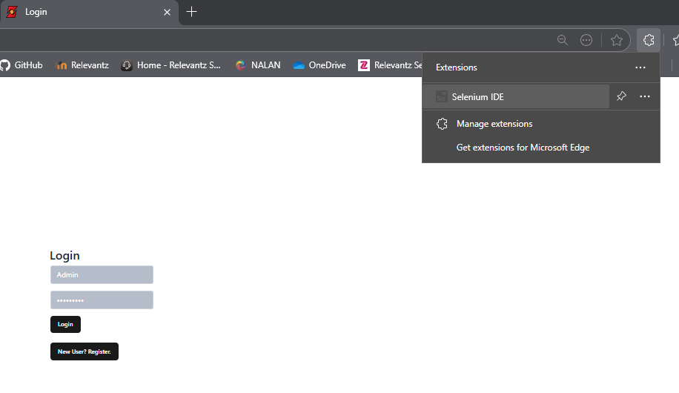

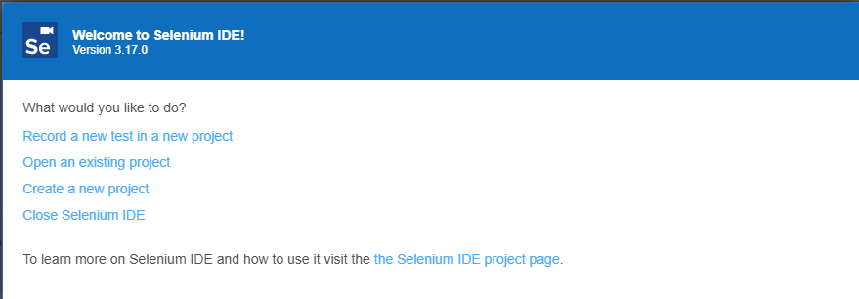

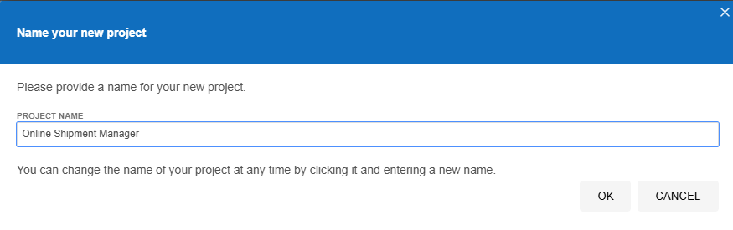
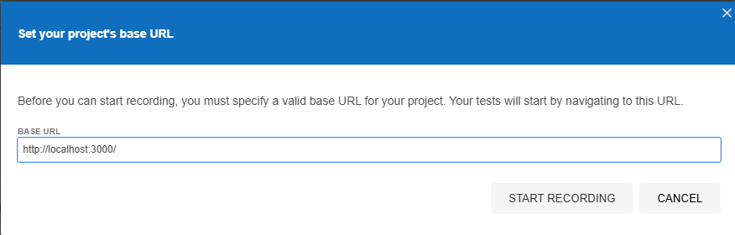

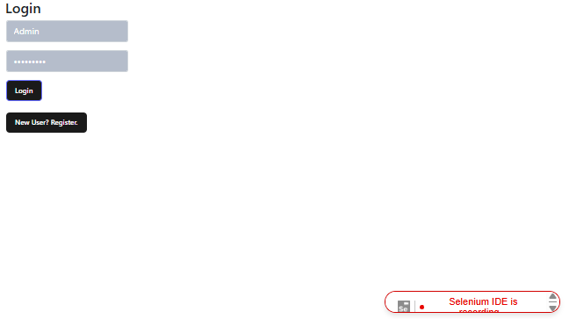

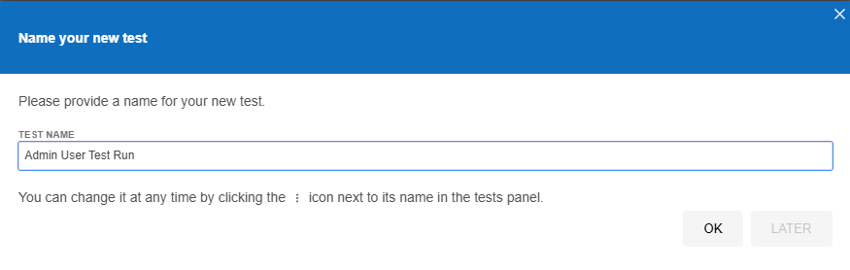
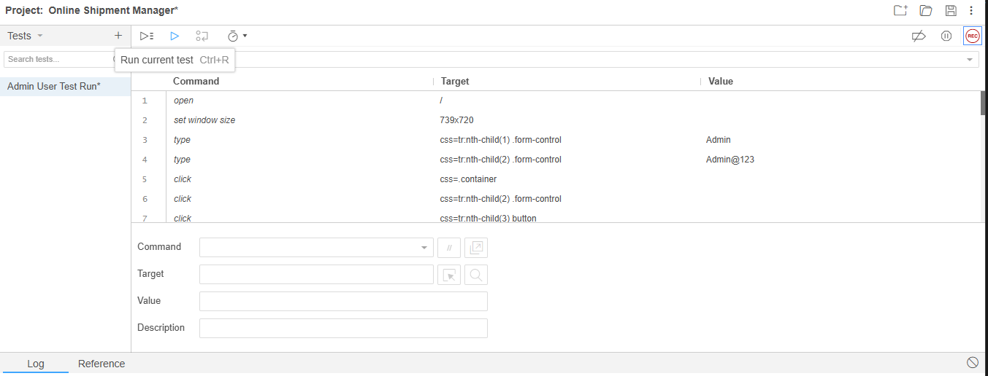

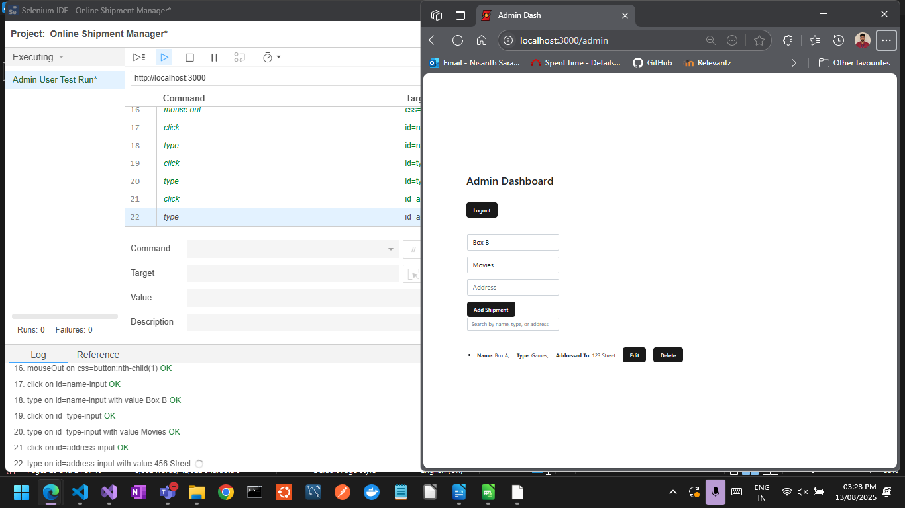

Code Base

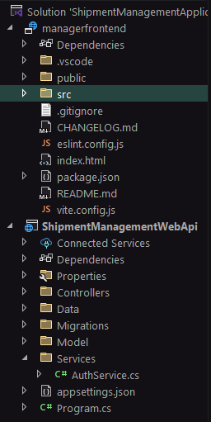
Backend:

/Services/AuthService.cs

using ShipmentManagementWebApi.Data;
using ShipmentManagementWebApi.Models;
using Microsoft.EntityFrameworkCore;

namespace ShipmentManagementWebApi.Services;

public class AuthService
{
private readonly AppDbContext _context;

public AuthService(AppDbContext context)
{
_context = context;
}

public User Authenticate(string username, string password)
{
return _context.Users.FirstOrDefault(u => u.Username == username && u.Password == password);
}

public bool Register(User user)
{
if (_context.Users.Any(u => u.Username == user.Username)) return false;
_context.Users.Add(user);
_context.SaveChanges();
return true;
}
}

appsettings.json

{
"Logging": {
"LogLevel": {
"Default": "Information",
"Microsoft.AspNetCore": "Warning"
}
},
"ConnectionStrings": {
"DefaultConnection": "Server=127.0.0.1;Port=3306;Database=ShipmentDb;User=root;Password=root"
},
"AllowedHosts": "*"
}

Program.cs

using Microsoft.EntityFrameworkCore;
using ShipmentManagementWebApi.Data;
using ShipmentManagementWebApi.Services;

var builder = WebApplication.CreateBuilder(args);

// Add services to the container.

builder.Services.AddControllers();
// Learn more about configuring Swagger/OpenAPI at https://aka.ms/aspnetcore/swashbuckle
builder.Services.AddEndpointsApiExplorer();
builder.Services.AddSwaggerGen();

// Configure EF Core with MySQL
builder.Services.AddDbContext<AppDbContext>(options =>
options.UseMySql(
builder.Configuration.GetConnectionString("DefaultConnection"),
ServerVersion.AutoDetect(builder.Configuration.GetConnectionString("DefaultConnection"))
));

// Register custom services
builder.Services.AddScoped<AuthService>();

builder.Services.AddCors(options =>
{
options.AddPolicy("AllowReactApp",
policy => policy
.WithOrigins("http://localhost:51097") // React dev server
.AllowAnyHeader()
.AllowAnyMethod());
});

var app = builder.Build();

app.UseCors("AllowReactApp");

// Configure the HTTP request pipeline.
if (app.Environment.IsDevelopment())
{
app.UseSwagger();
app.UseSwaggerUI();
}

app.UseHttpsRedirection();

app.UseAuthorization();

app.MapControllers();

app.Run();

/Models/User.cs

using System.ComponentModel.DataAnnotations;

namespace ShipmentManagementWebApi.Models
{
public class User
{
[Key]
public int Id { get; set; }
public string? Username { get; set; }
public string? Password { get; set; } // Plain text for simplicity
public string? Role { get; set; } = "User"; // Default role
}

}

/Models/Shipment.cs

using System.ComponentModel.DataAnnotations;

namespace ShipmentManagementWebApi.Models
{
public class Shipment
{
[Key]
public int Id { get; set; }
public string? Name { get; set; }
public string? Type { get; set; }
public string? Address { get; set; }
}
}

/Data/AppDbContext.cs

using Microsoft.EntityFrameworkCore;
using System.Collections.Generic;
using ShipmentManagementWebApi.Models;

namespace ShipmentManagementWebApi.Data
{
public class AppDbContext : DbContext
{
public AppDbContext(DbContextOptions<AppDbContext> options) : base(options) { }

public DbSet<User> Users { get; set; }
public DbSet<Shipment> Shipments { get; set; }

}
}

/Controllers/AuthController.cs

using Microsoft.AspNetCore.Mvc;
using ShipmentManagementWebApi.Services;
using ShipmentManagementWebApi.Models;

[ApiController]
[Route("api/[controller]")]
public class AuthController : ControllerBase
{
private readonly AuthService _authService;

public AuthController(AuthService authService)
{
_authService = authService;
}

[HttpPost("register")]
public IActionResult Register(User user)
{
user.Role = "User"; // Default role
if (_authService.Register(user)) return Ok("Registered successfully");
return BadRequest("Username already exists");
}

[HttpPost("login")]
public IActionResult Login(User user)
{
var loggedInUser = _authService.Authenticate(user.Username, user.Password);
if (loggedInUser == null) return Unauthorized("Invalid credentials");
return Ok(loggedInUser); // Return user object with role
}
}

/Controllers/ShipmentController.cs

using Microsoft.AspNetCore.Mvc;
using ShipmentManagementWebApi.Data;
using ShipmentManagementWebApi.Models;

[ApiController]
[Route("api/[controller]")]
public class ShipmentController : ControllerBase
{
private readonly AppDbContext _context;

public ShipmentController(AppDbContext context)
{
_context = context;
}

[HttpGet]
public IActionResult GetAll() => Ok(_context.Shipments.ToList());

[HttpGet("{id}")]
public IActionResult Get(int id)
{
var shipment = _context.Shipments.Find(id);
if (shipment == null) return NotFound();
return Ok(shipment);
}

[HttpPost]
public IActionResult Create(Shipment shipment, [FromQuery] string role)
{
if (role != "Admin") return Unauthorized("Only admin can create shipments");
_context.Shipments.Add(shipment);
_context.SaveChanges();
return Ok(shipment);
}

[HttpPut("{id}")]
public IActionResult Update(int id, Shipment updatedshipment, [FromQuery] string role)
{
if (role != "Admin") return Unauthorized("Only admin can update shipments");
var shipment = _context.Shipments.Find(id);
if (shipment == null) return NotFound();

shipment.Name = updatedshipment.Name;
shipment.Type = updatedshipment.Type;
shipment.Address = updatedshipment.Address;

_context.SaveChanges();
return Ok(shipment);
}

[HttpDelete("{id}")]
public IActionResult Delete(int id, [FromQuery] string role)
{
if (role != "Admin") return Unauthorized("Only admin can delete shipments");
var shipment = _context.Shipments.Find(id);
if (shipment == null) return NotFound();

_context.Shipments.Remove(shipment);
_context.SaveChanges();
return Ok("Deleted");
}
}

Frontend – React JS

/src/main.jsx

import React from 'react';
import ReactDOM from 'react-dom/client';
import App from './App';
import { AuthProvider } from './context/AuthContext';
import "./index.css";

const root = ReactDOM.createRoot(document.getElementById('root'));
root.render(
<AuthProvider>
<App />
</AuthProvider>
);

/src/App.jsx

import React, { useContext } from 'react';
import { BrowserRouter as Router, Routes, Route, Navigate } from 'react-router-dom';
import Login from './components/Login';
import Register from './components/Register';
import AdminDashboard from './components/AdminDashboard';
import UserDashboard from './components/UserDashboard';
import { AuthContext } from './context/AuthContext';
import "./App.css";

function App() {
const { user } = useContext(AuthContext);

return (
<Router>
<Routes>
<Route path="/" element={<Login />} />
<Route path="/register" element={<Register />} />
<Route path="/admin" element={user?.role === 'Admin' ? <AdminDashboard /> : <Navigate to="/" />} />
<Route path="/user" element={user?.role === 'User' ? <UserDashboard /> : <Navigate to="/" />} />
</Routes>
</Router>
);
}

export default App;

/services/api.js

//api.js
import axios from 'axios';

const API = axios.create({
baseURL: 'http://localhost:5099/api', // Adjust if needed
});

export default API;

/context/AuthContext.jsx

//AuthContext.jsx
import React, { createContext, useState } from 'react';

// eslint-disable-next-line react-refresh/only-export-components
export const AuthContext = createContext();

export const AuthProvider = ({ children }) => {
const [user, setUser] = useState(null); // Holds logged-in user

return (
<AuthContext.Provider value={{ user, setUser }}>
{children}
</AuthContext.Provider>
);
};

/components/Login.jsx

import React, { useState, useContext, useEffect } from 'react';
import { useNavigate } from 'react-router-dom';
import API from '../services/api';
import { AuthContext } from '../context/AuthContext';

function Login() {
const [username, setUsername] = useState('');
const [password, setPassword] = useState('');
const { setUser } = useContext(AuthContext);
const { user } = useContext(AuthContext);
const navigate = useNavigate();

const handleLogin = async () => {

if (username == '' || password == '') {
alert("All credentials are mandatory.");
return;
}

try {
const res = await API.post('/auth/login', { username, password });
setUser(res.data);
res.data.role === 'Admin' ? navigate('/admin') : navigate('/user');
} catch {
alert('Invalid credentials');
}
};

const handleRegister = () => {
navigate('/register');
}

useEffect(() => {
document.title = "Login";

if (user?.role == "Admin") {
navigate("/admin");
}
else if (user?.role == "User") {
navigate("/user")
}
});

return (
<>
<div class="container">
<h2>Login</h2>
<table>
<tr>
<td>
<div class="input-group input-group-lg mb-3">
<input class="form-control" placeholder="Username" onChange={e => setUsername(e.target.value)} />
</div>
</td>
</tr>
<tr>
<td>
<div class="input-group input-group-lg mb-3">
<input class="form-control" placeholder="Password" type="password" onChange={e => setPassword(e.target.value)} />
</div>
</td>
</tr>
<tr>
<td>
<button onClick={handleLogin}>Login</button>
</td>
</tr>
<br></br>
<tr>
<td>
<button onClick={handleRegister}>New User? Register.</button>
</td>
</tr>
</table>
</div>
</>
);
}

export default Login;

/components/Register.jsx

import React, { useState, useEffect, useContext } from 'react';
import { useNavigate } from 'react-router-dom';
import API from '../services/api';
import { AuthContext } from '../context/AuthContext';

function Register() {
const [username, setUsername] = useState('');
const [password, setPassword] = useState('');
const { user } = useContext(AuthContext);
const navigate = useNavigate();

const handleRegister = async () => {

if (username == '' || password == '') {
alert("All credentials are mandatory.");
return;
}

try {
await API.post('/auth/register', { username, password });
alert('Registration successful');
navigate("/");
} catch {
alert('Registration failed');
}
};

const handleLogin= () => {
navigate('/');
}

useEffect(() => {
document.title = "Register";

if (user?.role == "Admin") {
navigate("/admin");
}
else if (user?.role == "User") {
navigate("/user")
}
});

return (
<>
<div class="container">
<h2>Register</h2>
<table>
<tr>
<td>
<div class="input-group input-group-lg mb-3">
<input class="form-control" placeholder="Username" onChange={e => setUsername(e.target.value)} />
</div>
</td>
</tr>
<tr>
<td>
<div class="input-group input-group-lg mb-3">
<input class="form-control" placeholder="Password" type="password" onChange={e => setPassword(e.target.value)} />
</div>
</td>
</tr>
<tr>
<td>
<button onClick={handleRegister}>Register</button>
</td>
</tr>
<br></br>
<tr>
<td>
<button onClick={handleLogin}>Old User? Login.</button>
</td>
</tr>
</table>
</div>
</>
);
}

export default Register;

/components/AdminDashboard.jsx

import React, { useContext, useEffect, useState } from 'react';
import API from '../services/api';
import { AuthContext } from '../context/AuthContext';

function AdminDashboard() {
const { user } = useContext(AuthContext);
const [shipments, setShipment] = useState([]);
const { setUser } = useContext(AuthContext);
const [searchTerm, setSearchTerm] = useState('');
const [form, setForm] = useState({ name: '', type: '', address: ''});
const [editingId, setEditingId] = useState(null);

const fetchShipments = async () => {
const res = await API.get('/shipment');
setShipment(res.data);
};

const createOrUpdateShipment = async () => {

if (form.name == '' || form.type == '' || form.address == '') {
alert("All fields Needed!");
return;
}

if (editingId) {
await API.put(`/shipment/${editingId}?role=${user.role}`, form);
setEditingId(null);
} else {
await API.post(`/shipment?role=${user.role}`, form);
}
setForm({ name: '', type: '', address: '' });
fetchShipments();
};

const deleteShipment = async (id) => {
await API.delete(`/shipment/${id}?role=${user.role}`);
fetchShipments();
};

const startEdit = (shipment) => {
setForm(shipment);
setEditingId(shipment.id);
};

const filteredShipments = shipments.filter(s =>
s.name.toLowerCase().includes(searchTerm.toLowerCase()) ||
s.type.toLowerCase().includes(searchTerm.toLowerCase()) ||
s.address.toString().includes(searchTerm)
);

const logout = () => {
setUser(null);
};

useEffect(() => {
document.title = "Admin Dash";

fetchShipments();
}, []);

return (
<div class="container">
<h2>Admin Dashboard</h2>
<br></br>
<button onClick={logout} style={{ marginBottom: '1rem' }}>
Logout
</button>
<br></br>
<br></br>
<table>
<tr>
<td>
<div class="input-group input-group-lg mb-3">
<input class="form-control" placeholder="Name" value={form.name} onChange={e => setForm({ ...form, name: e.target.value })} />
</div>
</td>
</tr>
<tr>
<td>
<div class="input-group input-group-lg mb-3">
<input class="form-control" placeholder="Type" value={form.type} onChange={e => setForm({ ...form, type: e.target.value })} />
</div>
</td>
</tr>
<tr>
<td>
<div class="input-group input-group-lg mb-3">
<input class="form-control" placeholder="Address" value={form.address} onChange={e => setForm({ ...form, address: e.target.value })} />
</div>
</td>
</tr>
<tr>
<td>
<button onClick={createOrUpdateShipment}>
{editingId ? 'Update Shipment' : 'Add Shipment'}
</button>
</td>
</tr>
<br></br>
<br></br>
<br></br>
<tr>
<td>
<input
class="form-control"
placeholder="Search by name, type, or address"
value={searchTerm}
onChange={e => setSearchTerm(e.target.value)}
/>
</td>
</tr>
</table>
<ul>
{filteredShipments.map(s => (
<li key={s.id}>
<strong>Name:</strong> {s.name},&nbsp;&nbsp;&nbsp;&nbsp; <strong>Type:</strong> {s.type},&nbsp;&nbsp;&nbsp;&nbsp; <strong>Addressed To:</strong> {s.address} &nbsp;&nbsp;&nbsp;&nbsp;
<button onClick={() => startEdit(s)}>Edit</button> &nbsp;&nbsp;&nbsp;&nbsp;
<button onClick={() => deleteShipment(s.id)}>Delete</button>
</li>
))}
</ul>
</div>
);
}

export default AdminDashboard;

/components/UserDashboard.jsx

import React, { useContext, useEffect, useState } from 'react';
import API from '../services/api';
import { AuthContext } from '../context/AuthContext';

function UserDashboard() {
const [shipments, setShipment] = useState([]);
const [searchTerm, setSearchTerm] = useState('');
const { setUser } = useContext(AuthContext);

useEffect(() => {
document.title = "User Dash";

API.get('/shipment').then(res => setShipment(res.data));
}, []);

const logout = () => {
setUser(null);
};

const filteredShipments = shipments.filter(s =>
s.name.toLowerCase().includes(searchTerm.toLowerCase()) ||
s.type.toLowerCase().includes(searchTerm.toLowerCase()) ||
s.address.toString().includes(searchTerm)
);

return (
<div class="container">
<h2>User Dashboard</h2>
<br></br>
<button onClick={logout} style={{ marginBottom: '1rem' }}>
Logout
</button>
<br></br>
<br></br>
<table>
<tr>
<td>
<input
class="form-control"
placeholder="Search by name, type, or address"
value={searchTerm}
onChange={e => setSearchTerm(e.target.value)}
/>
</td>
</tr>
</table>
<br></br>
<br></br>
<ul>
{filteredShipments.map(s => (
<li key={s.id}>
<strong>Name:</strong> {s.name},&nbsp;&nbsp;&nbsp;&nbsp; <strong>Type:</strong> {s.type},&nbsp;&nbsp;&nbsp;&nbsp; <strong>Addressed To:</strong> {s.address} &nbsp;&nbsp;&nbsp;&nbsp;
</li>
))}
</ul>
</div>
);
}

export default UserDashboard;

